Running the Audio Recorder

Software Prerequisites:

1. MATLAB (preferably a 2014 or 2015 version) with DSP system toolbox
2. All Scarlett 18i8 drivers installed, including ASIO diver
3. Hardware
   1. No specified hardware is required for the audio recorder. If you wish to set up the system in its detection formation, see Section I of “Running Logistic Regression” for reference.
4. Prepare MATLAB
   1. Open MATLAB (we used 2015b for development).
   2. Add all folders and files that were provided in the drone detection software package to the active path.
   3. Under the “Home” tab, click “Preferences”. In “DSP System Toolbox” settings, select “ASIO” as the audio hardware API.

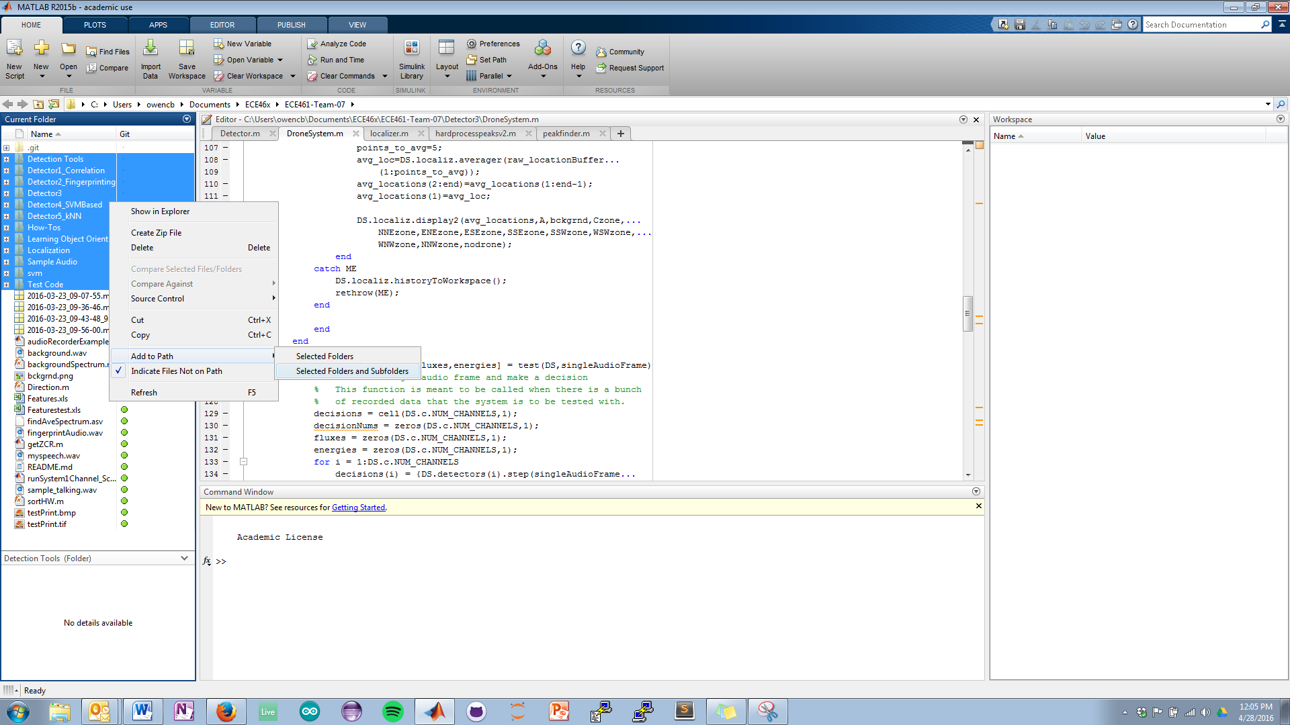

Figure : Adding folders to the path

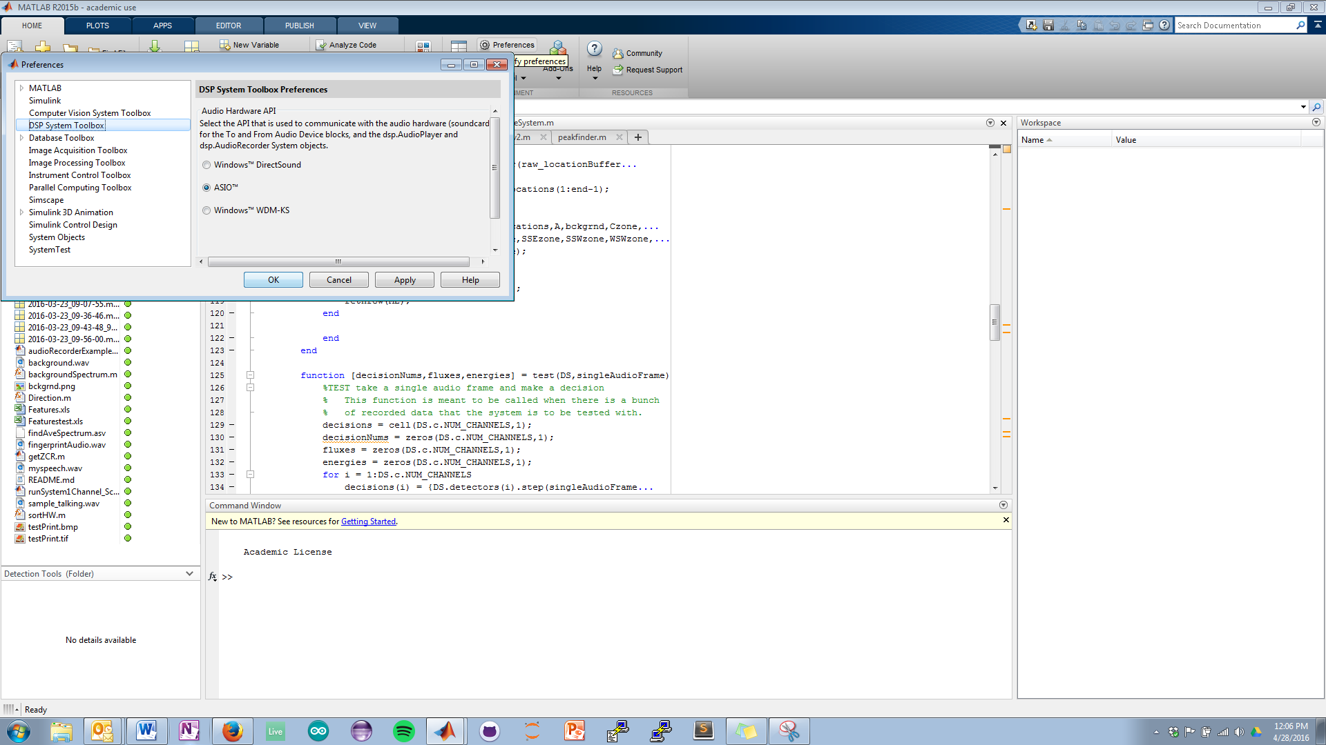

Figure : Switching to ASIO drivers

1. Run the system
   1. In the MATLAB command prompt, type RecordAudio4Channel or RecordAudio1Channel depending on how many channels you want to record.
   2. Press the “Save” button on the GUI to save approximately the last second’s worth of audio.
   3. Type in the file name and specify the directory.

Comments:

1. Gain knobs
   1. Always turn the knobs up to maximum when recording audio to be used for signal profiles. Other gains will screw up the logistic regression algorithm’s model.
   2. If the audio is not going to be put into signal profiles, feel free to use any gain level you feel is necessary.
   3. Be sure that the knobs are all at the same level; the detection system assumes this.
2. ASIO4ALL
   1. A free and trusted ASIO driver can be found here: <http://www.asio4all.com/>
3. The system depicted in figure 2 shows the microphones 50 feet away from the center of the system. Since the cables are exactly 50 feet and some slack is needed, the stands will be about 42-45 feet away.